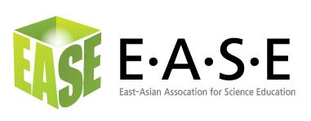
2011 Advertising Bill Form
East-Asian Association for Science Education

Bill to Company:
Contact Name
Bill to Address:

===================================================================
( ) Advertising LOGO on the EASE official Webpage. US$1,000.00 / year
( ) Advertising LOGO on 4 issues of EASE E-Newsletter. US$300.00 /4 issues

Total Amount Due (per above)
===================================================================
Type of Payment:
( ) Charge My Credit Card
Credit Card: VISA ( ) MasterCard ( )
Card Holder Name _______________________________________
Card number________________________________________
Expiration Date_____________________
CVC (the last three digits on the back) ___________
Card Holder Signature __________________________________
Date of Signature _______________________
(EASE will charge your Credit Card under the name of SEOUL DAEHAGGYOS (which means
“Seoul National University” in Korean expression)).

( ) Check Enclosed

( ) Remittance to Bank Account
Beneficiary Bank: KWANGJU BANK CHOSUN UNIVERSITY BR)
Swift Code: KWABKRSE
Bank Account: 004-107-508451
Name of Recipient: Young-Shin Park (EASE 2011)
Address of Recipient: INT’L. DEPT. 6FL. INYOUNG BLDG. 44-11, YOIDO-DONG, YOUNGDEUNGPO-GU, SEOUL, 150-890, KOREA, YOIDO, P.O.BOX 422
BENE’S TEL NO; +82-10-4225-6745
===================================================================
Please return Order Form (plus information on the ad material) with payment via fax to 82-62-230-7935 or by email (with attached file) to Dr. Young-Shin PARK (easeheadquarter@gamil.com), or mail to:
Dr. Young-Shin PARK
Secretary Office, East-Asian Association for Science Education
#4210 Natural science bldg., Chosun University. Gwangju, KOREA (501-759)

Thank you for advertising with EASE!

