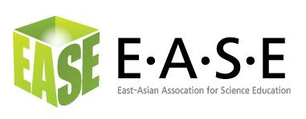
Advertising Bill Form
East-Asian Association for Science Education

Bill to Company:
Contact Name
Bill to Address:

===================================================================□ Advertising LOGO on the EASE official Webpage. US$1,000.00 / year
- Advertising LOGO on four issues of EASE E-Newsletter. US$300.00 / year

Total Amount Due (per above)
===================================================================
Type of Payment:
- Credit Card
Credit Card: VISA ( ) MasterCard ( )
Card Holder Name _______________________________________
Card number □□□□-□□□□-□□□□-□□□□
Expiration Date □□/20□□
CVC (the last three digits on the back) ___________
Card Holder Signature __________________________________
Date of Signature _______________________
(EASE will charge your Credit Card under the name of National Changhua University of Education.)

===================================================================

Please return Order Form (plus information on the ad material) with payment via fax to +852 29487563 by email (with attached file) to Dr. Wan, Zhihong Peter (wanzh@ied.edu.hk), or mail to the address below.

Peter Zhihong Wan,
Room 33, Floor 1, Building D1,
The Hong Kong Institute of Education,
10 Lo Ping Road, Tai Po, New Territories, Hong Kong SAR, China

TEL: +852-29488696

Thank you for advertising with EASE!

